Octameter

📏 What is Octameter
# Source: Chatgpt (GPT-4-turbo) at [8/2/2025]
Octameter is a poetic meter consisting of eight metrical feet per line. Due to its unusual length (often 16+ syllables), it's rarely used in traditional English poetry but can appear in experimental or highly rhythmic verse forms.

🧱 Structure
# Source: Chatgpt (GPT-4-turbo) at [8/2/2025]
- 8 metrical feet per line
- Common patterns (though rare overall):
  - Iambic octameter (16 syllables)
  - Trochaic octameter (16 syllables)
- Tends to feel heavy, grand, or mechanical if overused
- Lines may contain caesuras to balance the rhythm and ease reading

📝 Example (Trochaic Octameter)
# Source: Chatgpt (GPT-4-turbo) at [8/2/2025]
Once upon a midnight dreary, while I pondered, weak and weary...
— Edgar Allan Poe, "The Raven" (Line is almost pure trochaic octameter)
Gently gliding through the cosmos, stars beneath our vessel stream
— Sample iambic octameter (16 syllables)

🧬 Variants
# Source: Chatgpt (GPT-4-turbo) at [8/2/2025]
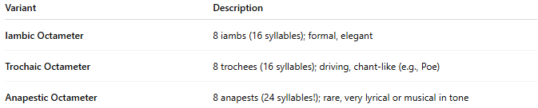
Variant | Description
Iambic Octameter | 8 iambs (16 syllables); formal, elegant
Trochaic Octameter | 8 trochees (16 syllables); driving, chant-like (e.g., Poe)
Anapestic Octameter | 8 anapests (24 syllables!); rare, very lyrical or musical in tone

🎭 Effect in Poetry
# Source: Chatgpt (GPT-4-turbo) at [8/2/2025]
- Feels expansive, musical, or majestic
- Works well for dramatic monologues, oratory, or stylized narrative
- Risk of feeling monotonous or too dense without variation

📚 Where It's Found
# Source: Chatgpt (GPT-4-turbo) at [8/2/2025]
Octameter is occasionally used in:
- Narrative poetry (especially romantic or Gothic)
- Dramatic or lyrical verse
- Experimental poetry
- Notable examples: Poe’s “The Raven”, though even Poe mixes meters for flexibility

